**Asian Options Monte Carlo Pricing under the Lévy Lognormal Approximation**

*Dimitrasopoulos, Theo; Kraemer, Will; Rajguru, Snehal; Seshadri, Vaikunth*

*(intentionally left blank)*

**Table of Contents:**

* ~~General Description~~
* Pricing Algorithm
* Performance Benchmarks
* Hedging Analysis
* Next Steps

**Alternative table of contents so that it follows a journal-style scientific paper:**

* Abstract
* ~~Introduction~~
* ~~Materials and Methods~~
* Results
* Discussion
* Acknowledgments
* References/Literature
* Appendices (potentially some more graphs, but not code as it’s not customary + it would take 36 letter-paper pages to put it all in).

**General Description:**

Asian Options are an exotic derivative where the payoff is determined by the average price of the underlying asset over its maturity **T**. The payoffs of an Asian Call and Put are calculated as follows:

$Asian Call Payoff: max\{K-S_{avg},0\}$

$Asian Put Payoff : max\{S_{avg}-K, 0\}$

Where K is the strike price, and $S_{avg}$ is the average price of the underlying asset. The average asset price can be calculated arithmetically or geometrically, which must be stipulated in the contract.

$Arithmetic Mean:A_{n} =\frac{1}{n}*\sum_{i=1}^{n}{}S_{i}$

$Geometric Mean:G_{n}=\sqrt[n]{\prod_{i=1}^{n}{}S_{i}}$

Asian options using the arithmetic averaging procedure are more common than those using geometric averaging.

Most Asian option contracts are said to be averaging-in style. Averaging-in style contracts will sample at discrete and regular time intervals i.e weekly, monthly, quarterly, or annually averaging from inception to maturity date. Conversely, if an Asian option is averaging-out style the average is computed using specific samples near the maturity date. Generally speaking, averaging-out style options are more risky than averaging-in style options since the uncertainty of future spot prices is higher the further in time from the start of the contract. Averaging-out style Asian options have an increased risk exposure to spot price and volatility which is reflected in their higher price.

Arithmetic Asian option prices can only be estimated using numerical methods such as Monte Carlo, because the arithmetic average of log-normal variables are not log-normal themselves. However, an analytical closed form formula for geometric asian options can be adapted from the Black-Scholes formula as geometric averages of log-normal variables also follow a lognormal distribution in a risk neutral world. Kemna and Vorst (1990) offer a good approximation for an geometric Asian option using the Black-Scholes formula which will be discussed in the pricing algorithm section.

Compared to similar ‘vanilla’ exchange traded derivatives Asian options are attractive as their volatility is low due to the averaging mechanics of its payout. Consequently, Asian options are less expensive than their corresponding vanilla derivatives. Furthermore, the higher number of observations, the lower the price of the Asian option. For this reason Asian options are a favored hedging tool of actors in volatile markets such as commodities, foreign exchange, and energy. Consider an airline that steadily buys crude oil whose supply price is not fixed, but set weekly from a particular benchmark. The airline may hedge themselves against a spike in oil by using a tailored Asian option to reflect the weekly purchases. This would be less expensive and more convenient than buying a basket of European options expiring at weekly intervals. Asian options may also be beneficial in markets with low volume, as the derivative would protect against price manipulation of the underlying asset.

**Pricing Algorithm:**

*Detailed description of the pricing algorithm chosen for the derivative considered, and sample results obtained with dummy data. This includes test results, sensitivity to inputs and parameters of the numerical algorithm (e.g. sensitivity to the choice of the time step).*

The team’s pricing algorithm utilizes some of the methods in Kemna and Vorst [1]. The pricing formula for geometric average Asian options given are:

**Asian Call Option: $G_{C}(K,T)=e^{-rT}[G_{0}N(d_{1})-KN(d_{2})]$**

**Asian Put Option: $G_{P}(K,T) = e^{-rT}[KN(-d_{2})-G_{0}N(-d_{1})]$**

With

$d_{1,2}=\frac{1}{Σ_{G}\sqrt{T}}(log(\frac{G_{0}}{K}±\frac{1}{2}{Σ^{2}}_{G}T), Σ_{G}=\frac{1}{\sqrt{3}}σ$

And

$G_{0}=S_{0}e^{\frac{1}{2}(r-q)T-\frac{1}{12}σ^{2}T}$

**Geometric Brownian Path Generation:**

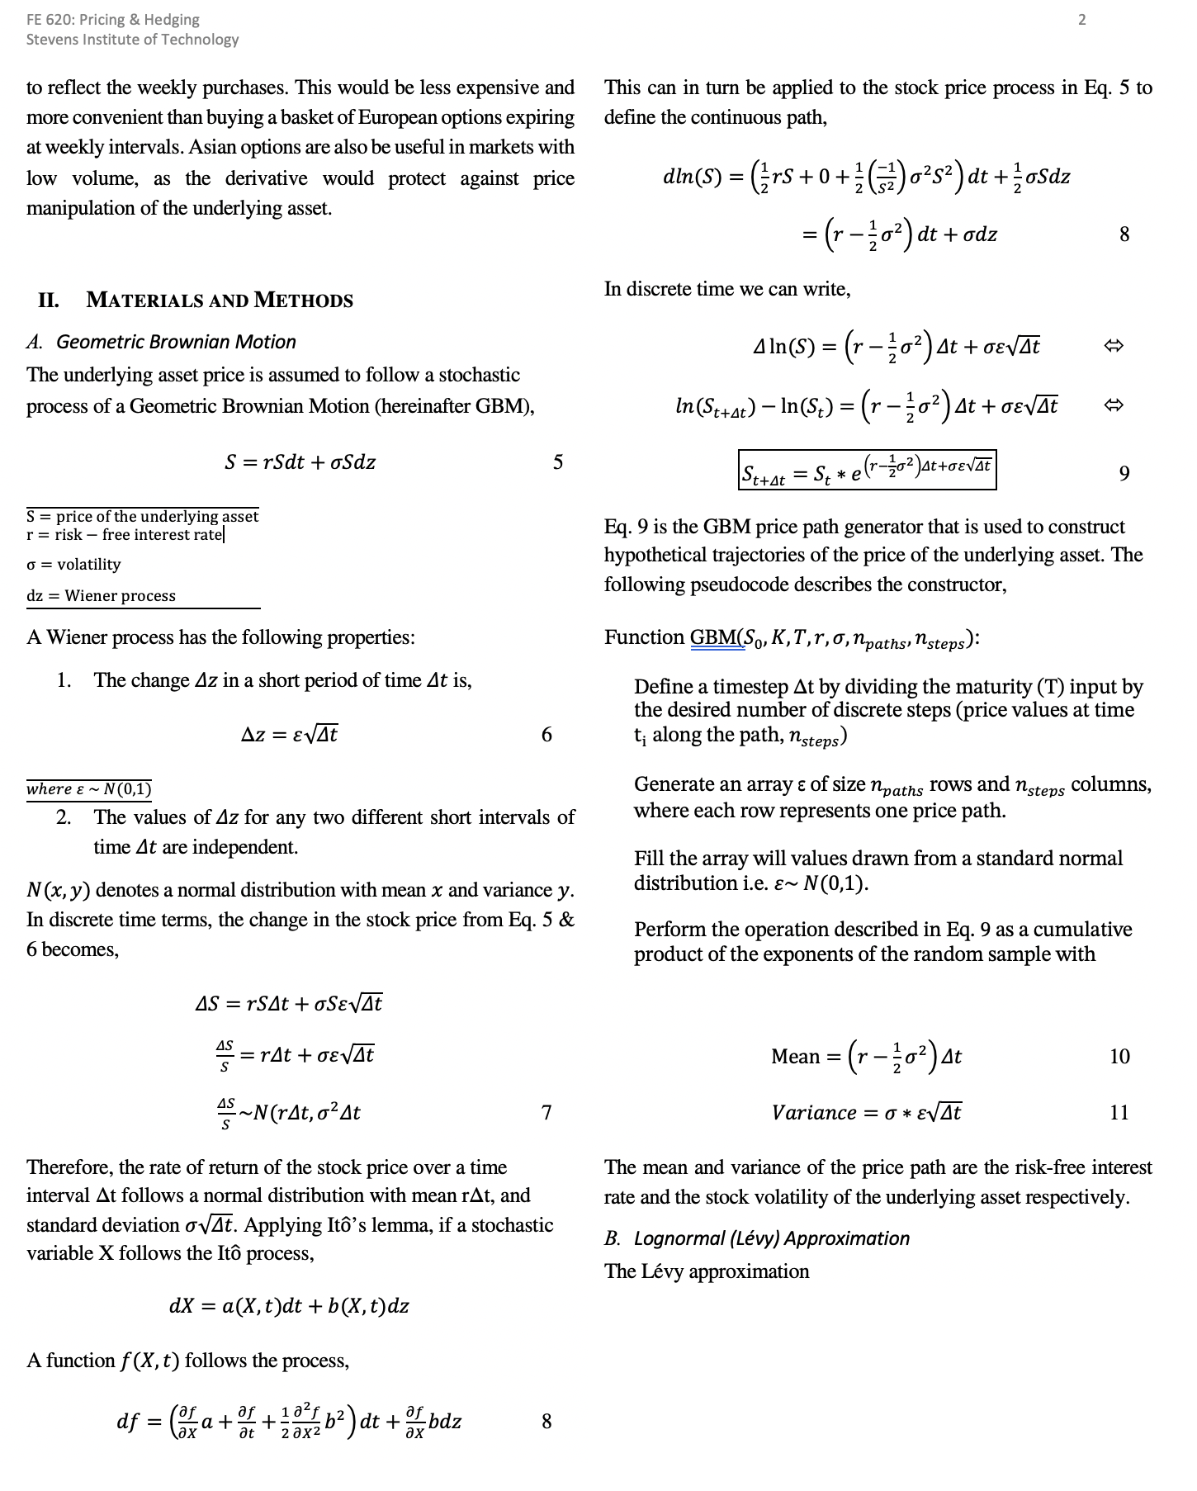

**Performance Benchmarks:**

Asian options are rarely traded on an underlying stock of a publicly traded company within NYSE or NASDAQ making information on these options impossible to obtain from Yahoo Finance. However, these options are commonly used on commodities, most commonly on oil futures. This information is commonly available on CME (Chicago Mercantile Exchange). Since we were not paying members of their website, we could only get prices and other information on the options at the time and not past data. This meant that we would have to keep checking their websites for updated prices. Having been introduced to Dr. Vadim Linetsky’s work on arithmetic options, we decided to compare his results with our own pricer on geometric asian options. Dr. Linetsky used the eigenfunction expansion approach that has yielded results deemed to be the most accurate arithmetic average computation.In both cases of arithmetic and geometric average pricing tests, we use the Black-Scholes-Merton option price as a control and the result that most accurately reflects the true mean of the option price. In our implementation of a variance reduction technique in the model, we use the geometric average option payoff as a control variate to calibrate the accuracy of the arithmetic average component of the algorithm.

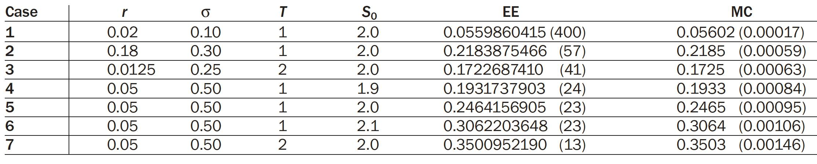

*Fig X. A summary of results of average options from Dr. Linetsky’s paper*

From the pricer that we were able to create using Python, we were able to achieve very similar results to what Dr. Linetsky had achieved making this a success in our eyes.

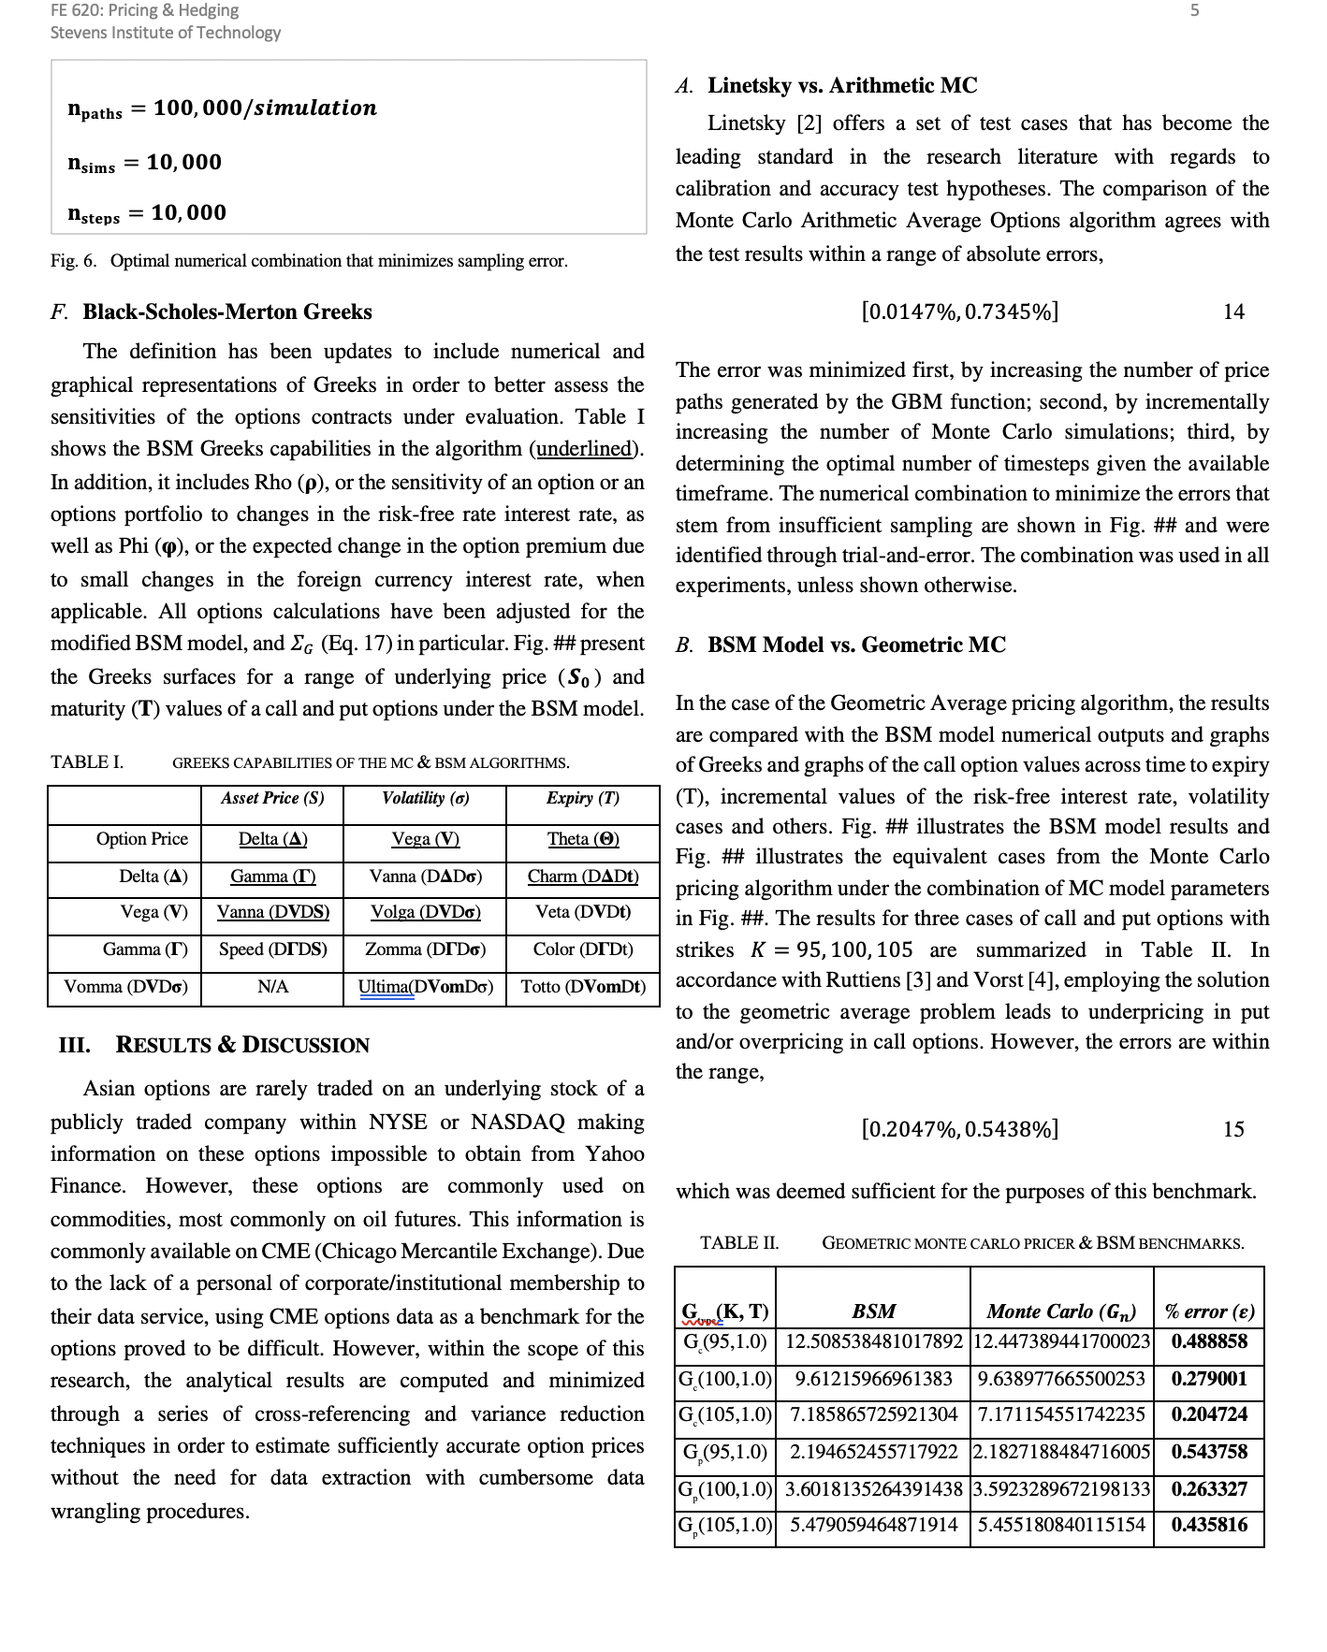

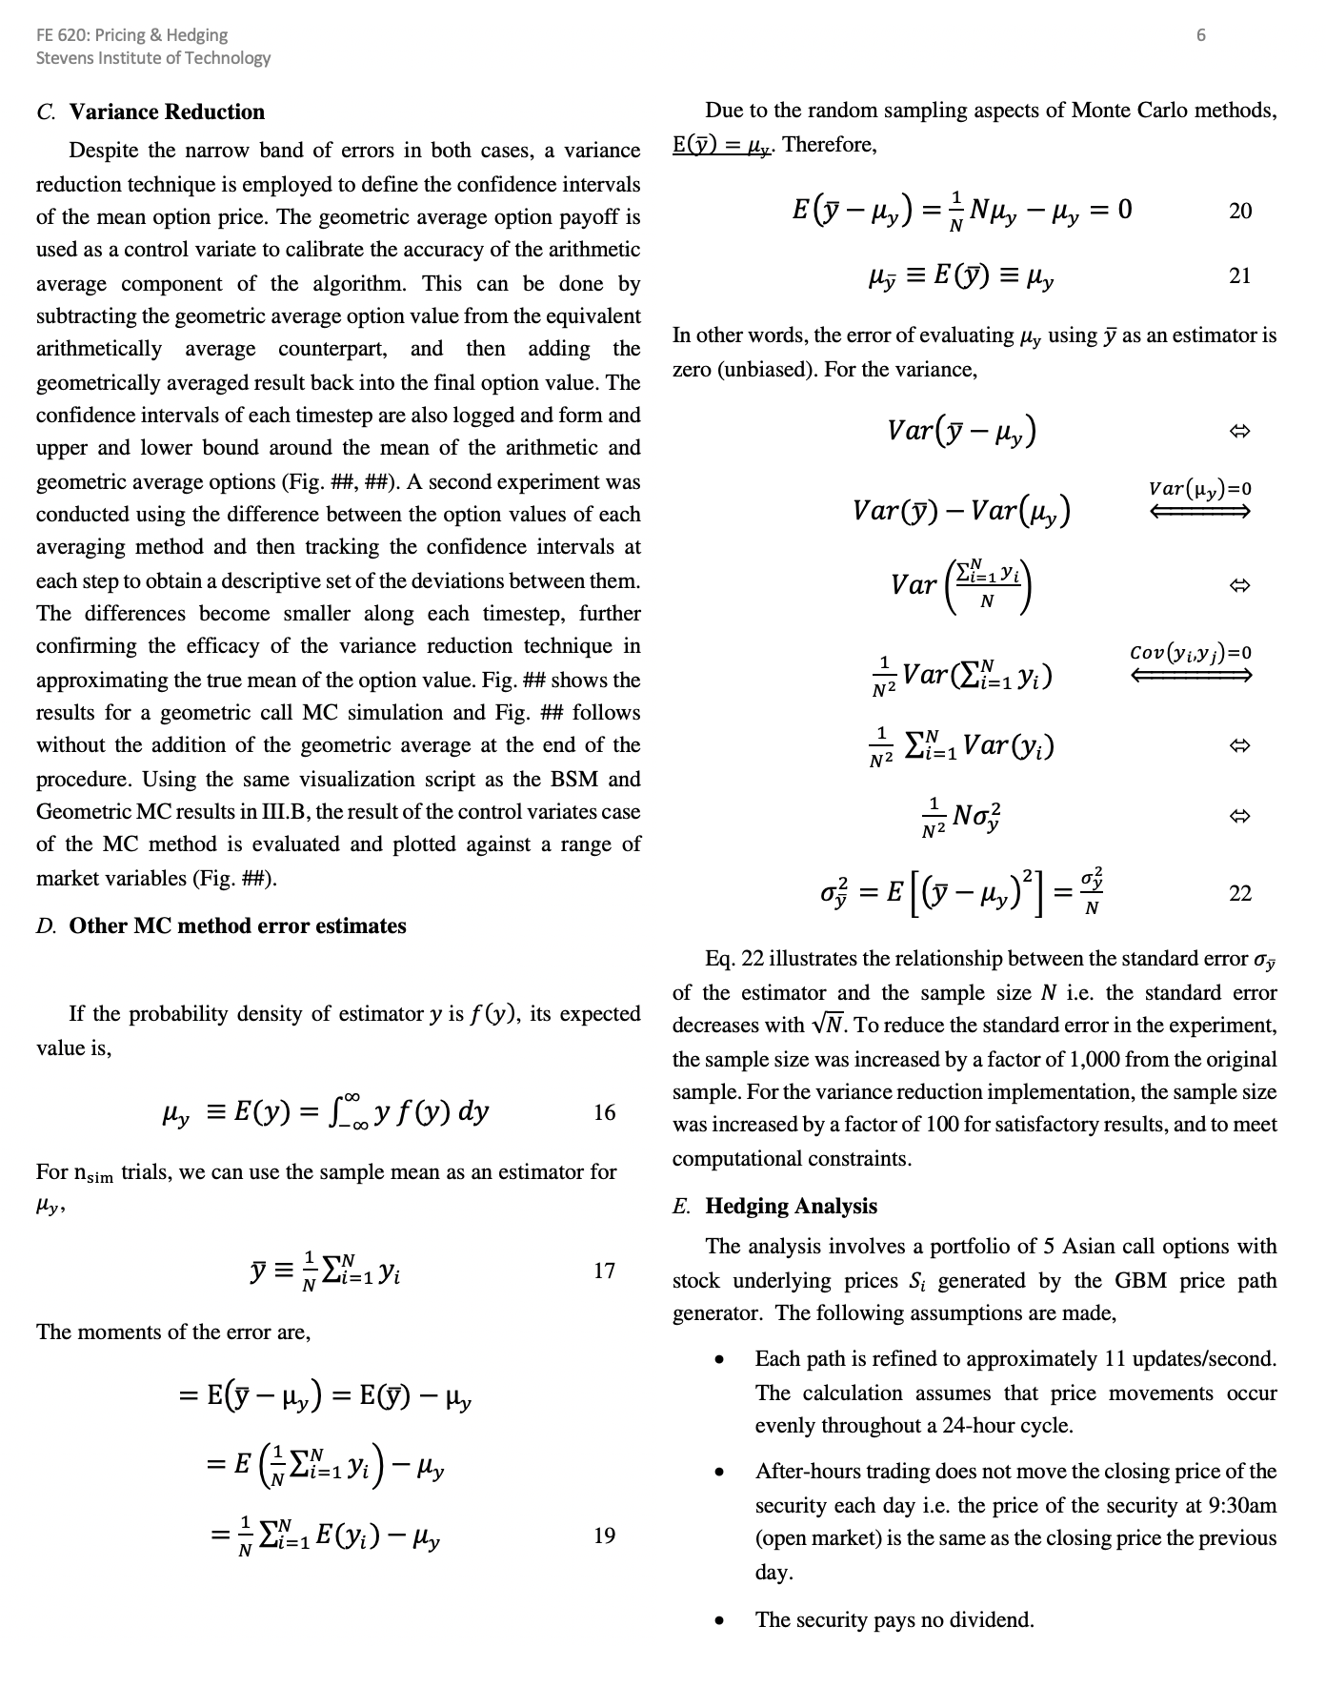

**Table XX.XX: Results of the Geometric Average Monte Carlo Simulator using the test cases in Linetsky (2004).**

|  |  |  |  |  |  |  |
| --- | --- | --- | --- | --- | --- | --- |
| **Type** | **r** | **σ** | **S0** | **Linetsky** | **Monte Carlo** | **Error (%)** |
| Gc(K=2,T=1) | 0.02 | 0.10 | 2.0 | 0.0559860415 | 0.05597783853 | **0.01465181790** |
| Gc(K=2,T=1) | 0.18 | 0.30 | 2.0 | 0.2183875466 | 0.21704705055 | **0.61381524305** |
| Gc(K=2,T=2) | 0.0125 | 0.25 | 2.0 | 0.172268741 | 0.17261298949 | **0.19983224447** |
| Gc(K=2,T=1) | 0.05 | 0.50 | 1.9 | 0.1931737903 | 0.19175486551 | **0.73453277003** |
| Gc(K=2,T=1) | 0.05 | 0.50 | 2.0 | 0.2464156905 | 0.24725425141 | **0.34030337475** |
| Gc(K=2,T=1) | 0.05 | 0.50 | 2.1 | 0.3062203648 | 0.30663616405 | **0.13578432300** |
| Gc(K=2,T=2) | 0.05 | 0.50 | 2.0 | 0.350095219 | 0.34756912761 | **0.72154409743** |

Table (initial variables) shows the base case that was used in the Monte Carlo Geometric Average implementation. 100000 iterations with 100000 time steps per simulation was deemed as the optimal combinations of values to achieve the smallest absolute error in the price estimate.

**Table XX.XX: Initial Variables for the Geometric Monte Carlo Simulator**

|  |  |
| --- | --- |
|  | **Value** |
| Initial Asset Price (*S0*) | 100 |
| Risk-free rate (*r*) | 0.15 |
| Dividend Yield Rate (*q*) | 0.00 |
| Time to expiry (*T*) | 1.00 |
| Strike (*K*) | 95 |
| Implied Volatility (*σ, sigma*) | 0.3 |
| Number of Monte Carlo iterations (*it*) | 100,000 |
| Time Steps (*N*) | 100,000 |
| Price Paths / simulation | 1,000,000 |

**Hedging Analysis:**

Principle and test results. What are the main risks of the derivative, and how can they be hedged?

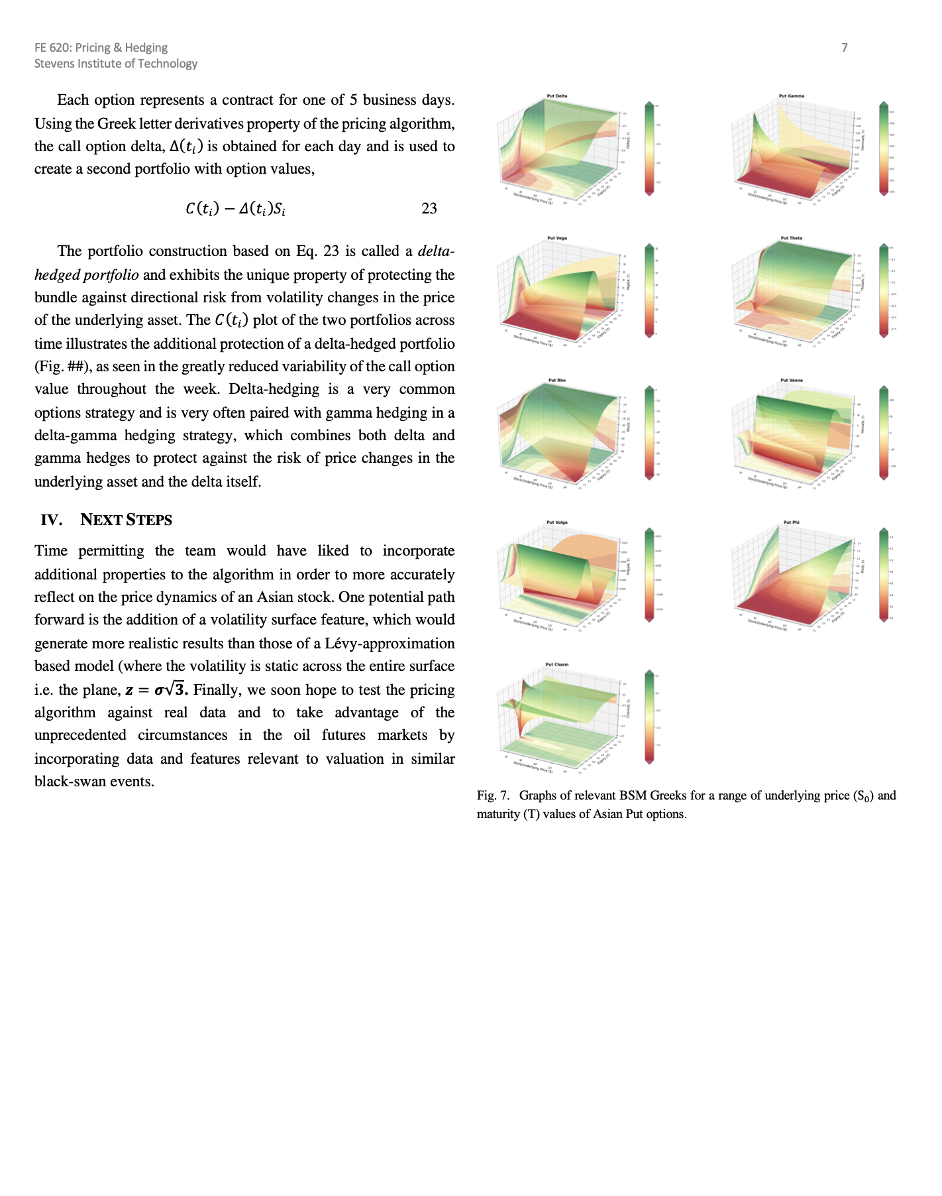

**Next Steps:**

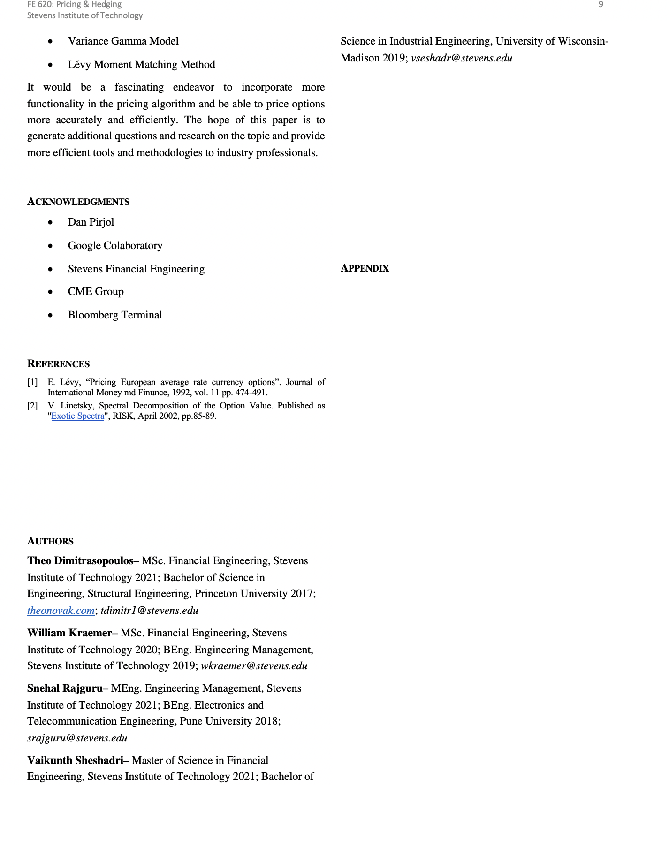

Time permitting the team would have liked to incorporate additional properties to the pricer in order to more accurately reflect on the price dynamics of an Asian stock. One potential path forward is the addition of a volatility surface feature, which would generate more realistic results than those of a Levy-approximation based model (where the volatility is static across the entire surface i.e. the plane,

$z=σ\sqrt{3}$

Some other Asian Options pricing algorithms developed over the years include:

* Path Integral Approach - Effective Classical Potential
* Rogers & Shi’s PDE
* Variance Gamma Model
* Lévy Moment Matching Method

**References:**

**Results:**

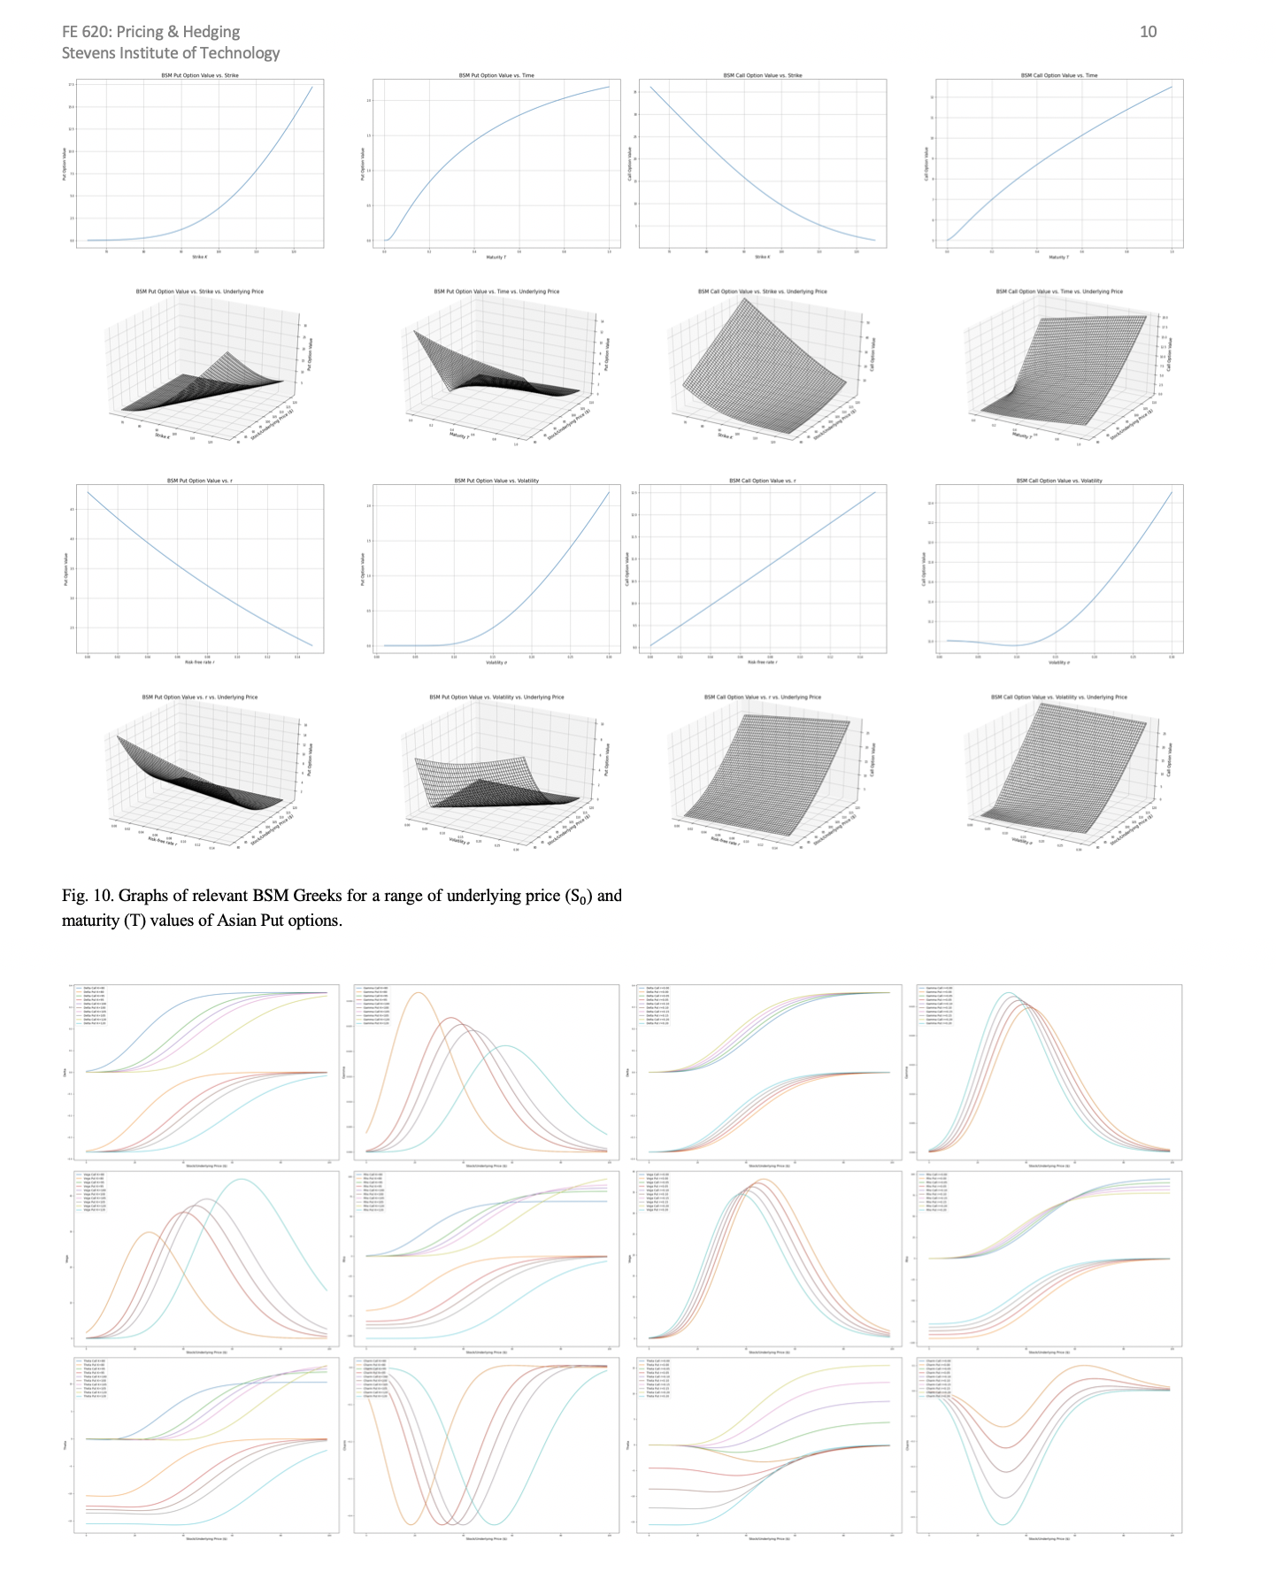

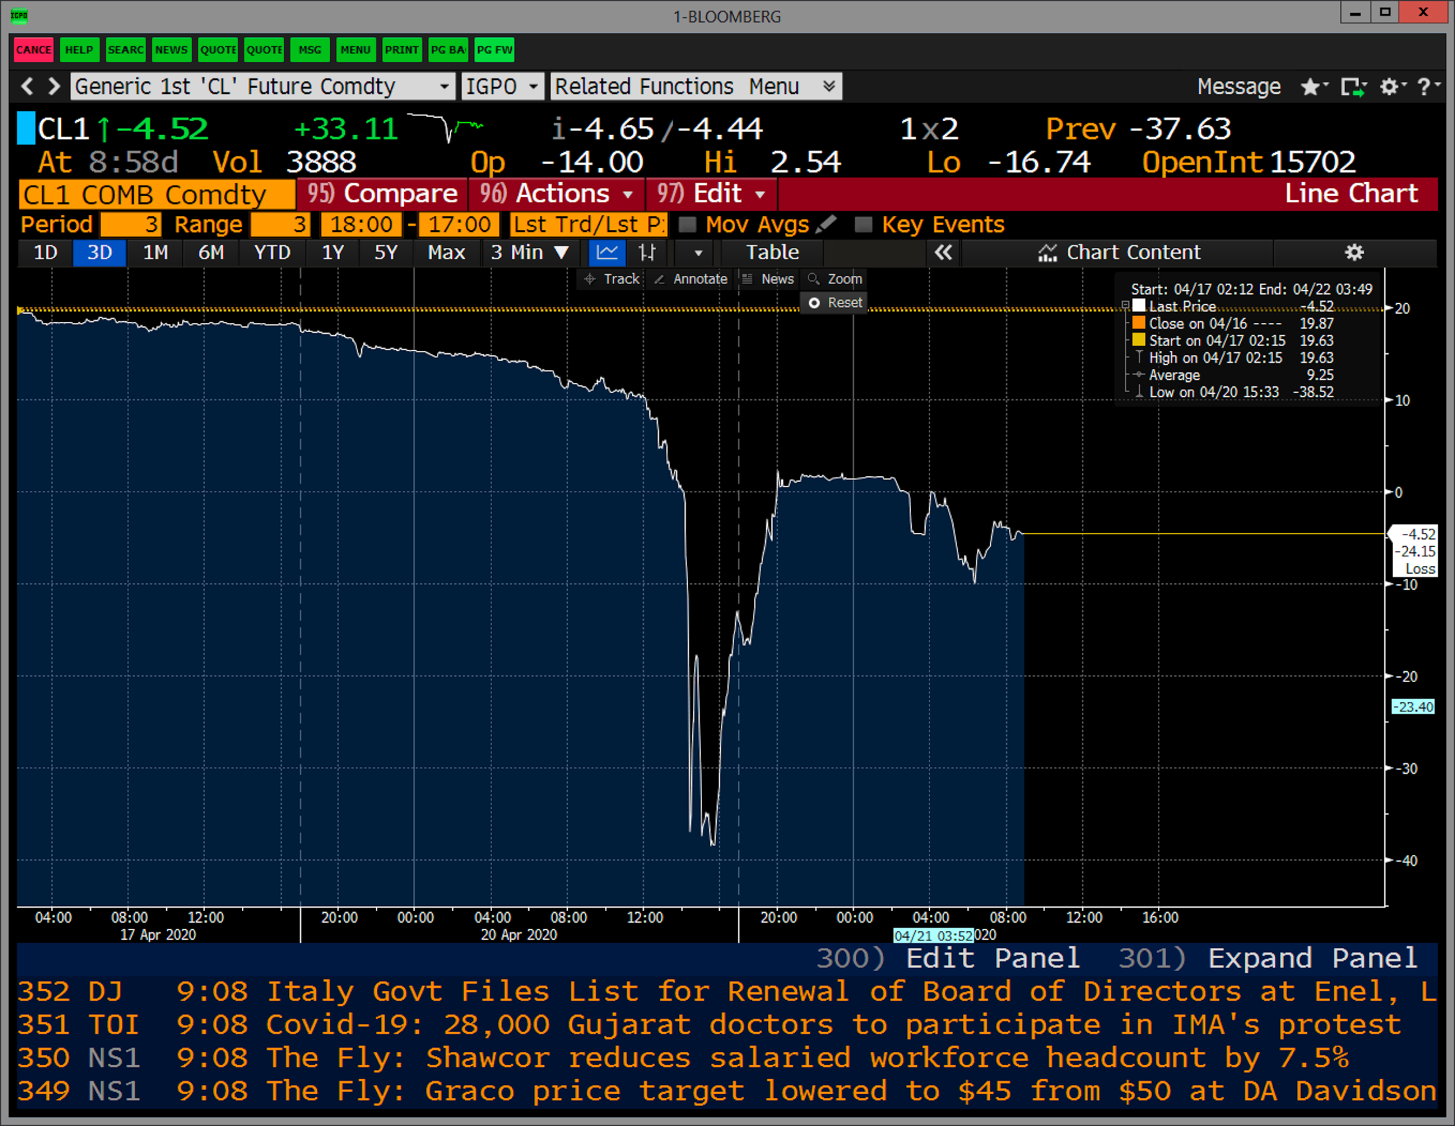

**References:**

[**Mohamed Bouzoubaa, Adel Osseiran - Exotic Options and Hybrids (2010)**](https://drive.google.com/file/d/1uEwyTONfeexlYVQnl6pfA4OJsfYg3Svo/view?usp=sharing)**.**